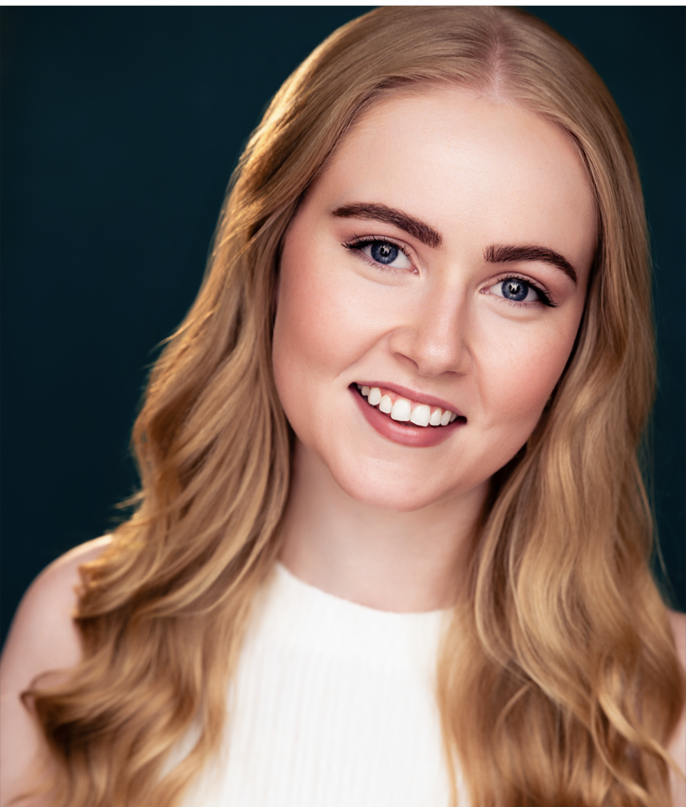
Abigail Boyce
Vocal Range: A3-E6
Eyes: Blue Cell Phone: 832-331-2839
Hair: Blonde Email: AbigailBoyceActor@gmail.com
Height: 5’4 Website: abigailboyceactor.com

Theatre
The Rocky Horror Show Phantom/Understudy Janet Art Factory Houston/ Dir. Colton Berry and Luke Hamilton
The Gondoliers Chorus Houston Gilbert and Sullivan Society/ Dir. Alyssa Weathersby
The Grippe (Staged Reading) Margaret Main Street Theater/ Dir. James Mirrione
Blithe Spirit Elvira Stageworks Theater/ Dir. Kiara Fischer
Holiday Follies Ensemble Stageworks Theater
Into the Woods Cinderella Lubbock Moonlight Musicals/ Dir. Kelsie Curry-Rendon
The Addams Family Wednesday Addams Lubbock Moonlight Musicals/ Dir. Tom Laney III
The Sound of Music Ensemble Nun Lubbock Moonlight Musicals
Sweet Charity Ursula March Texas Tech University/ Dir. Kyla Olson
A Little Night Music Mrs. Nordstrom Texas Tech University/ Dir. Casey Joiner-Isaacs

Training
Texas Tech University- B.F.A in Musical Theatre
Acting: Dean Nolen, Brad Frenette, Stephen Weatherbee, Bill Gelber, Rachel Hirshorn-Johnson,
Voice: Shayna Isaacs, Casey Joiner Isaacs, Rachel Hirshorn-Johnson, Brad Frenette
Dance: Kyla Olson, Ali Duffy, Kristine Olson, Yvonne Racz, Erin Alvarado
Vocal Instruction Emma Hayden, Alicia Gianni
Masterclass (Acting and Voice work through song) Kristin Chenoweth
Advanced Acting (Duet scene work) David Rainey (Studio for Actors Houston)
Alliance Audition Prep (Monologue and audition work) David Rainey (Studio for Actors Houston)
Skills Guitar, Beginner Piano, Horseback Riding (Western) Drawing/ Painting, Dance (Jazz, Contemporary, Ballet, Musical Theatre) Stage Combat (Sword, Rapier, Unarmed) Singing, Conversational Spanish, Softball, Character Voices

Dialects Queen’s English, Cockney, Irish, Northern Irish, Brooklyn, Texas, American Southern

